INSTRUCTION MANUAL

ICE MAKER

Model: QC-1

THANK YOU FOR CHOOSING OUR ICE CUBE MAKER
PLEASE READ THE MANUAL CAREFULLY BEFORE OPERATING
IMPORTANT NOTICES
When using an electrical appliance, basic safety precautions should always be followed to reduce the risk of fire, electric shock, and/or injury, including the following:
- Read all instructions before using.
- Remove all packing material and carefully check your ice maker to ensure it is in good condition and that there is no damage to the ice maker or power cord and plug.
- If the supply cord is damaged, it must be replaced by the manufacturer, its service agent or a similarly qualified person in order to avoid any hazard.
- This appliance is not intended to be used by persons (including children) with reduced physical, sensory and/or mental capabilities, or lack of experience and knowledge, unless they have been given supervision or instruction concerning the use of the appliance by a person responsible for their safety. Children should be supervised to ensure that they do not play with the appliance.
- This appliance can be used by children aged from 8 years and above. Persons with reduced physical, sensory and/or mental capabilities or lack of experience and knowledge, if they have been given supervision or instructions concerning use of the appliance in a safe way and understand the hazards involved. Children shall not play with the appliance. Cleaning and user maintenance shall not be done by children without supervision.
- This appliance is intended to be used in a household or similar environments such as:
- staff kitchen areas in shops, offices and other working environments;
- farm houses and by clients in hotels, motels and other residential type environments;
- bed and breakfast type environments;
- etcetera.
- Warnings:
- Do not store explosive or flammable substances such as aerosol cans with a flammable propellant in this appliance;
- Keep the ventilation openings in the appliance enclosure or in the built-in structure clear of obstruction;
- Do not use mechanical devices or other means to accelerate the defrosting process, other than those recommended by the manufacturer;
- Do not damage the refrigerant circuit;
- Do not use electrical appliances inside the water storage compartments of the appliance, unless they are recommended by the manufacturer;
- When positioning the appliance, ensure the supply cord is not trapped or damaged;
- Do not locate multiple portable socket-outlets or portable power supplies at the rear of the appliance.
- When disposing of the appliance, do so only at an authorized waste disposal center;
- Do not expose to flames;
- Fill with potable water only;
- Connect to potable water supply only.
- The refrigerant (R600a) is flammable.
 Caution: risk of fire / Flammable materials
The refrigerant isobutene (R600a) is contained within the refrigerant circuit of the appliance. A natural gas with a high level of environmental compatibility, which is nevertheless flammable. During transportation and installation of the appliance, ensure that none of the components of the refrigerant circuit gets damaged. If the refrigerant circuit could be damaged:
- Avoid opening flames or other sources of ignition;
- Thoroughly ventilate the room in which the appliance is situated.
- Before using the Ice maker for the first time, please wait 2 hours after positioning it and keep the transparent lid open for at least 2 hours.
- Pure water is not allowed to be used on this unit, spring water is recommended.
- Ensure the voltage is compliant with the voltage range stated on the rating label and ensure the earthing of the socket is in good condition.
- Do not upend this product or incline it over a 45℃ angle.
- To protect against risk of an electrical shock, do not pour water on the power cord, plug or ventilation.
- Do not immerse the appliance in water or any other liquid.
- Unplug the appliance after using or before cleaning.
- Keep the appliance 8 cm from other objects to ensure the good heat releasing.
- Do not use accessories which are not recommended by the manufacturer.
- Do not use the appliance close to flames, hot plates or stoves.
- Do not switch on the power button frequently (ensure 5min. interval at least) to avoid the damage of the compressor.
- Do not use outdoors.
- Never clean with scouring powders or hard implements.
- Please keep the instruction manual.
- To avoid contamination of food, please respect the following instructions:
- Opening the door for long periods can cause a significant increase of the temperature in the compartments of the appliance;
- Clean regularly surfaces that can come in contact with food and accessible drainage systems;
- Clean water tanks if they have not been used for 48 h; flush the water system connected to a water supply if water has not been drawn for 5 days;
- If the refrigerating appliance is left empty for long periods, switch off, defrost, clean, dry, and leave the door open to prevent mold developing within the appliance.
Regarding the information pertaining to the use of the appliance, please refer to the paragraphs below.

SPECIFICATIONS
BrandName: QuickCubes
Model Number: QC-1
Voltage: 220-240V/50Hz
Power Consumption: 120 W
Daily Ice Output: 12kg/24 hours
Ice Storage Capacity: 1.0L/600g
Water Reservoir Capacity: 1.0L
N.W: 6.52kg
G.W: 7.05kg
Compression-Type Refrigeration: 220-240V/50Hz
Cooling Agent: R600a environmental friendly refrigerant
Max Overall Dimensions (W \XDXH): 206X268X282mm
Packing Dimensions (LXWXH): 235X318X290mm

DESCRIPTION
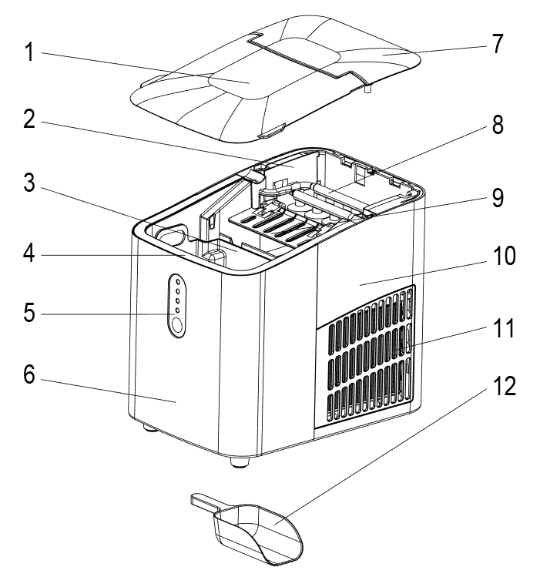

- Transparent lid
- Micro switch support
- Ice collecting tray
- Water tank
- Control panel
- Front Housing
- Top Lid
- Evaporator
- Ice shovel board
- Rear housing
- Air vent
- Ice scoop

FEATURE
- Quick ice making
- Prompt when the ice is full and water is insufficient
- Bullet transparent ice
- 8 pcs of ice can be made in six / seven minutes
1. During transportation, do not tilt the machine more than 45 degrees and do not tilt the machine upside down. This may damage the compressor and the sealing system.
2. Remove all packing materials, check the machine carefully and make sure that the machine, power cord and plug are normal.
3. The machine should be on a level surface. To ensure sufficient ventilation, the distance of the back of ice maker to the wall should be at least 150 mm. It should be away from the oven, radiator or other heat source.
4. Before using the machine for the first time, place the machine and leave the transparent cover open for at least two hours.
5. Make sure that the home voltage is consistent with the voltage indicated by the machine.
6. When the ambient temperature is lower than 15 degrees, please choose small ice. When the ambient temperature is higher than 30 degrees, it is recommended to choose large ice.
7. Do not use chemicals, acidic or alkaline liquids to make ice.

CONTROL PANEL OPERATION
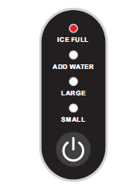
START/PAUSE button
ICE FULL: Ice full alarm indicator light
ADD WATER: Water shortage alarm indicator light
LARGE: Large ice indicator light
SMALL: Small ice indicator light

- START ICE PROCESS: Plug in the power, the machine is in standby mode, and the small ice indicator light flashes green. Press the START/PAUSE button, the indicator lights of small ice and large ice flash alternately and enter the ice cube size selection mode. When the corresponding indicator light lights up, press the START/PAUSE button again, and the machine starts to work. The corresponding indicator lights up for a long time, and the ice cube production starts. After the ice making is completed, the ice is shedded, and the machine enters the deicing function, and so on.
- CLEANING FUNCTION: Plug in the power cord and press the START/PAUSE button to start the machine. Then press the START/PAUSE button for 2 seconds. The machine enters the cleaning function and the four lights flash alternately. Do not disconnect the power supply during cleaning. After cleaning, the machine will automatically enter the standby mode.
- ADD WATER: when this light is on, it means water shortage in the water tank. You need to add water and press the START/PAUSE button to restart the machine.
- ICE FULL: When the ice reaches the maximum amount of ice storage container, this indicator light is on and the machine stops. At this time, the ice needs to be poured out. When the ice position is lower than the full sensor position, the machine will restart automatically.

OPERATING INSTRUCTIONS
Step 1
Open the lid, take out the ice collecting tray and add water to the reservoir.
Note: There is a maximum scale “MAX” in the reservoir. The water should not exceed the “MAX” position. If the water exceeds the maximum scale “MAX”, you need to open the bottom drain plug, release the excess water and cover with a transparent cover.
Step 2
Plug in the power cord and press the START/PAUSE button to start the machine.
1. The first three cycles when using the machine for the first time, the ice produced is small and irregular.
2. When the ice collecting tray is full, please take out the ice immediately. Do not let the ice overflow the ice collecting tray.

CLEANING & USE GUIDANCE
- Clean the inner liner, ice collecting tray, water tank and ice shovel frequently. When cleaning, unplug the unit and remove the ice cubes. Use a diluted solution of water and vinegar to clean the inside and the outside surface of the Ice maker. Rinse thoroughly before using again.
- Keep ventilation openings in the appliance enclosure or in the built-in structure clear of obstruction. Do not use mechanical devices or other means to accelerate the defrosting process, other than those recommended by the manufacturer.
- Reusing the machine after being idled for a period of time, it may not be able to pump enough water up. This will be caused by an air blockage. In this case, the water shortage indictor sign is displayed, just repress START/PAUSE button to restart the ice maker.
- To ensure the cleanness of ice, please change the water from the water reservoir at least once one day. If the machine is not being used for a long time, please drain the water out and clean it up.
- If the compressor does not work due to lack of water, ice full, power failure, etc, it will delay for 3 minutes to start up after restarted.
- Always use fresh water before starting ice production either at initial installation or after a long shut-off period.
- According to the actual use of the machine, the filter screen in the water tank shall be regularly cleaned after disassembly to prevent the water inlet from being blocked by scale. As shown in the figure below.
Take out the ice collecting tray, filter cover from the water tank in turn, clean the filter cover with clean water with a brush, and then put them back in place.

Ice collecting tray

Filter cover

TROUBLESHOOTING
- Please note, if a power failure occurs due to disconnection of the power cord or the power button has been pushed during an ice making cycle, small ice chips may formed and lodge in the automatic shovel causing it to jam. If this occurs, the ice chips can be removed by disconnecting the power cord and gently pushing the shovel to the rear of the cabinet. Once the ice chips have been removed, the machine can be restarted.
- Please check if the water reservoir is flat when the ice shovel cannot remove the ice to the ice collecting tray. If not, please push the ice shovel gently by finger, then press START/PAUSE button to restart.

PROBLEM | POSSIBLE CAUSE | SUGGESTED SOLUTIONS
The compressor works abnormally with a buzzing noise. | The voltage is lower than  Recommended. | Stop the ice maker and do not restart until the voltage is normal.
Water shortage indicator light is on. | 1.There is no water.  2.The pump is full of air. | 1. Add some water until it reaches MAX position  2. Press START/PAUSE button to restart the machine
Indicator lights on control panel are not on. | Blown fuse/ No power | Replace fuse / Turn power on
The ice made is too large and with pieces sticking together. | - Ice of previous cycles left in the water tray. | Take out the ice under the standby state.
The ice making process was correct, but no ice came out. | - The compressor has no refrigerant.  - Compressor damaged.  - Fan motor damaged. | Contact the seller.
All indicator lights flash at the same time. | 1. The water box is blocked by ice.  2. The motor is stuck, or the motor falls off, or the motor is damaged.  3. Micro switch damaged. | 1. Take out the ice under the ice shovel, plug in power again, and press the POWER button. After 3 minutes, the machine will restart automatically.  2. Contact the seller.
The machine has been working, but the water has been warming. | Solenoid broke down. | Replace the solenoid valve.
When the ice is full, the machine does not display the ice full icon. | - Ice full sensor damaged.  - Solar light interference. | - Replace the ice full sensor.  - Place the machine indoor.  - Contact the seller.
- If the power cord is damaged, it must be replaced by the manufacturer, its service agent or a similarly qualified person in order to avoid a hazard.
- Fill with potable water only.
- It is normal for the compressor and condenser surface to reach temperatures between 70°C and 90°C during operation. Surrounding areas may get very hot.
- Due to fast freezing, ice cubes may seem opaque. This is air trapped in the water and will not affect the quality or the taste of the ice.
- This appliance is not intended for use by persons (including children) with reduced physical, sensory or mental capabilities or lack of experience and knowledge, unless they have been given supervision or instruction concerning the use of the appliance by a person responsible for their safety.
- Children should be supervised to ensure that they do not play with the appliance.
- Do not immerse in water.
Correct Disposal of this product
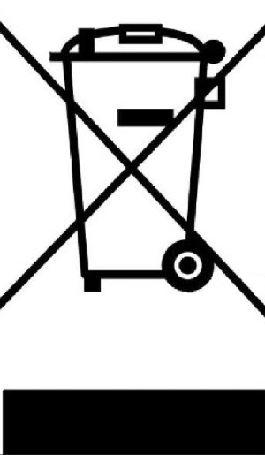 | This marking indicates that this product should not be disposed with other household wastes throughout the EU. To prevent possible harm to the environment or human health from uncontrolled waste disposal, recycle it responsibly to promote the sustainable reuse of material resources. To return your used device, please use the return and collection systems or contact the retailer where the product was purchased. They can take this product for environmental safe recycling.

